SET 11 – Product Category Analysis
Q1. Pie Chart
category <- c("Electronics","Clothing","Appliances")
sales <- c(50000,35000,40000)
pie(sales,
labels=category,
col=c("skyblue","pink","lightgreen"),
main="Sales Distribution by Product Category")
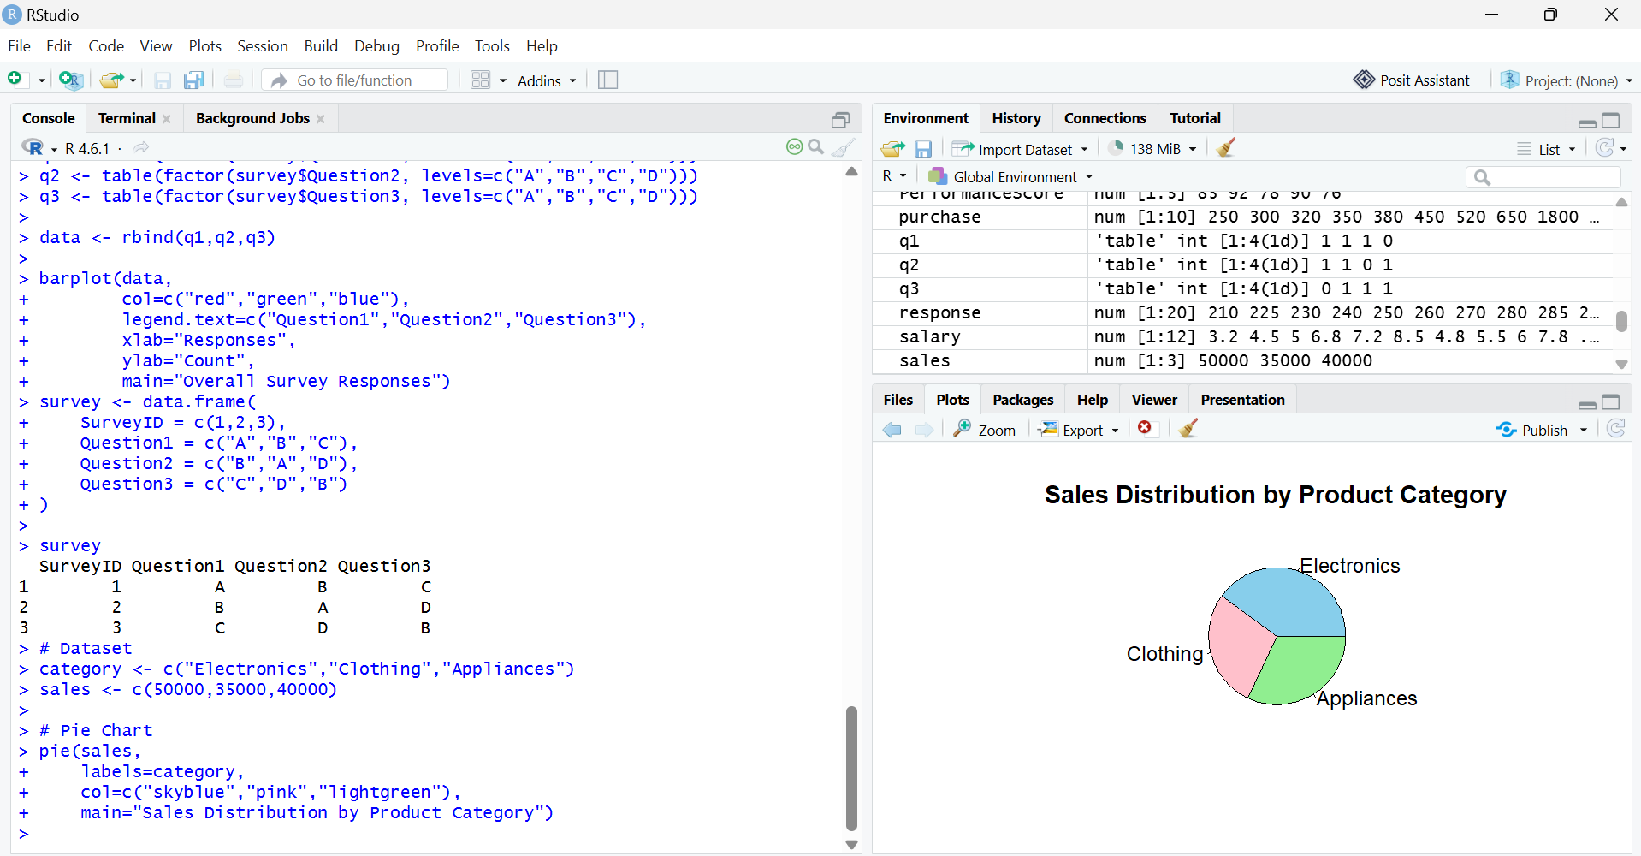

Q2. Funnel Chart
category <- c("Electronics","Clothing","Appliances")
sales <- c(50000,35000,40000)
par(mar=c(5,8,4,2))
barplot(rev(sales),
names.arg=rev(category),
horiz=TRUE,
col="steelblue",
xlab="Sales ($)",
main="Sales Conversion Funnel")
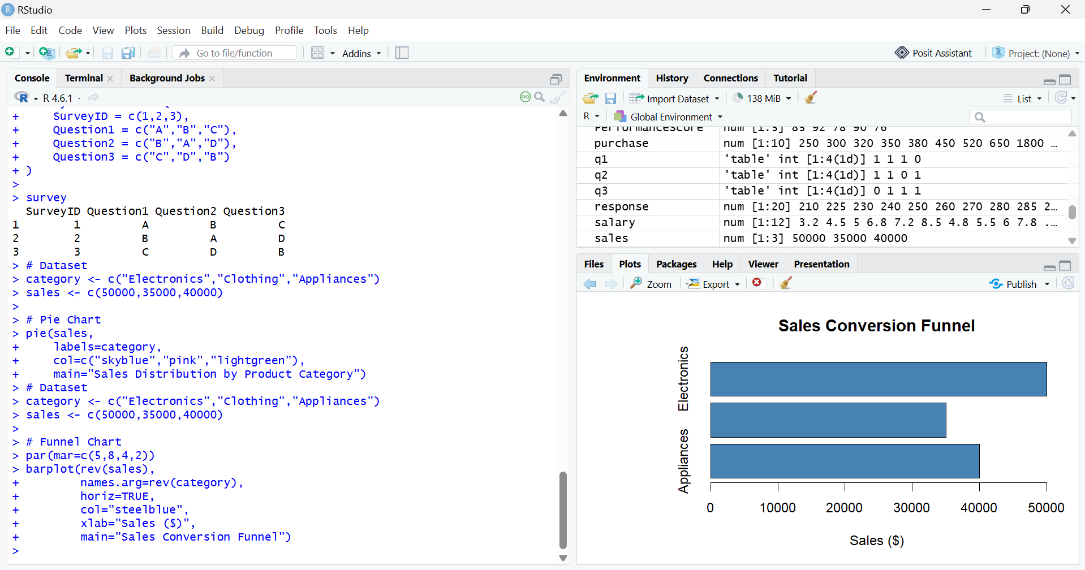

Q3. Table
product <- data.frame(
Category=c("Electronics","Clothing","Appliances"),
Sales=c(50000,35000,40000)
)
Product
